Module Name: Login Page
Test Case ID: 183
Webpage URL: https://practicetestautomation.com/

● Scenario ID:
Scenario: Invalid Username
Test Steps:
- Open Login Page
- Invalid Username
- Valid Password
- Login

Screenshots: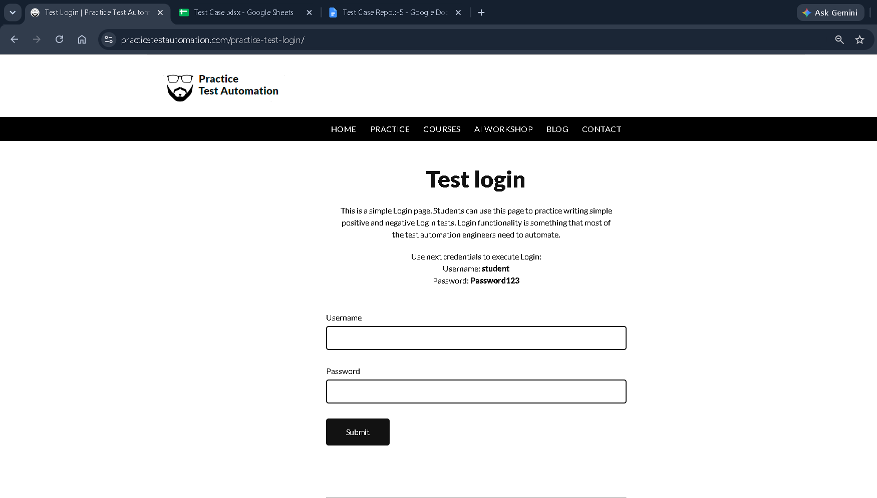

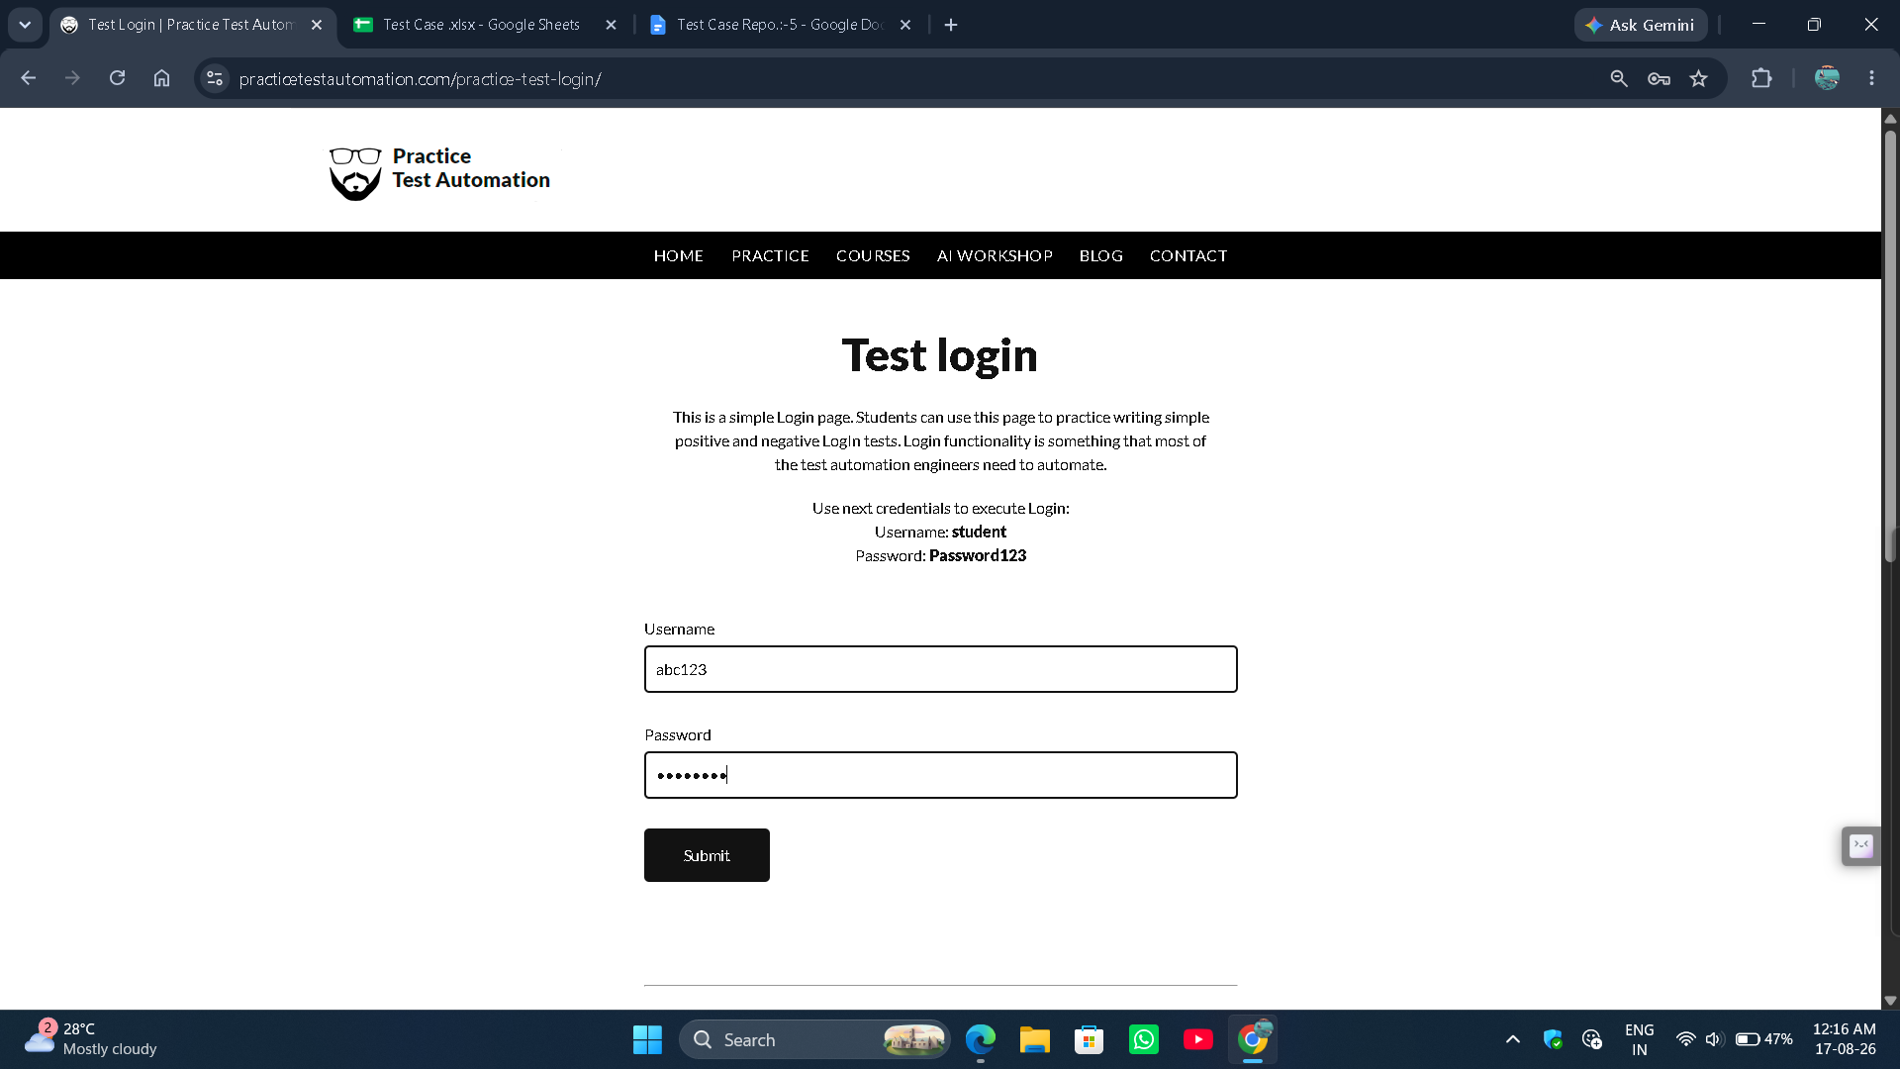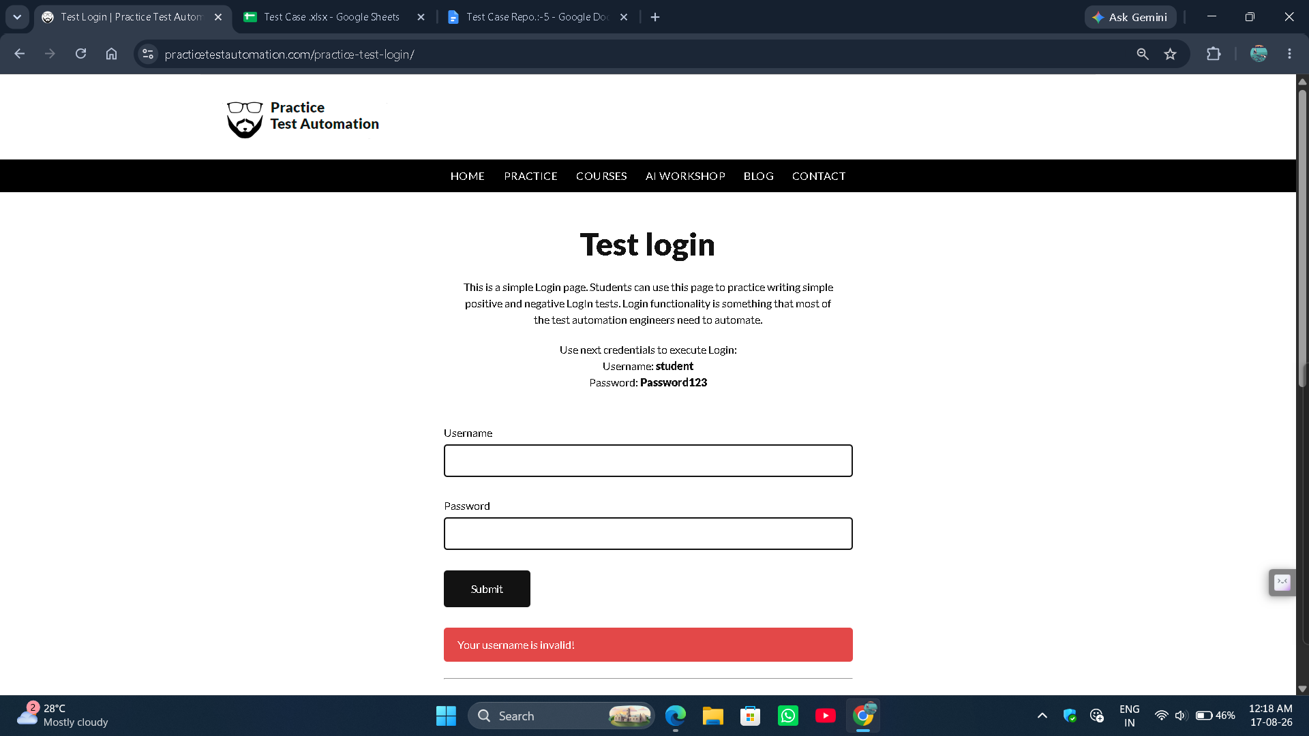

● Scenario ID: 5b
Scenario: Invalid Password
Test Steps:
- Open Login Page
- Valid Username
- Invalid Password
- Login

Screenshots: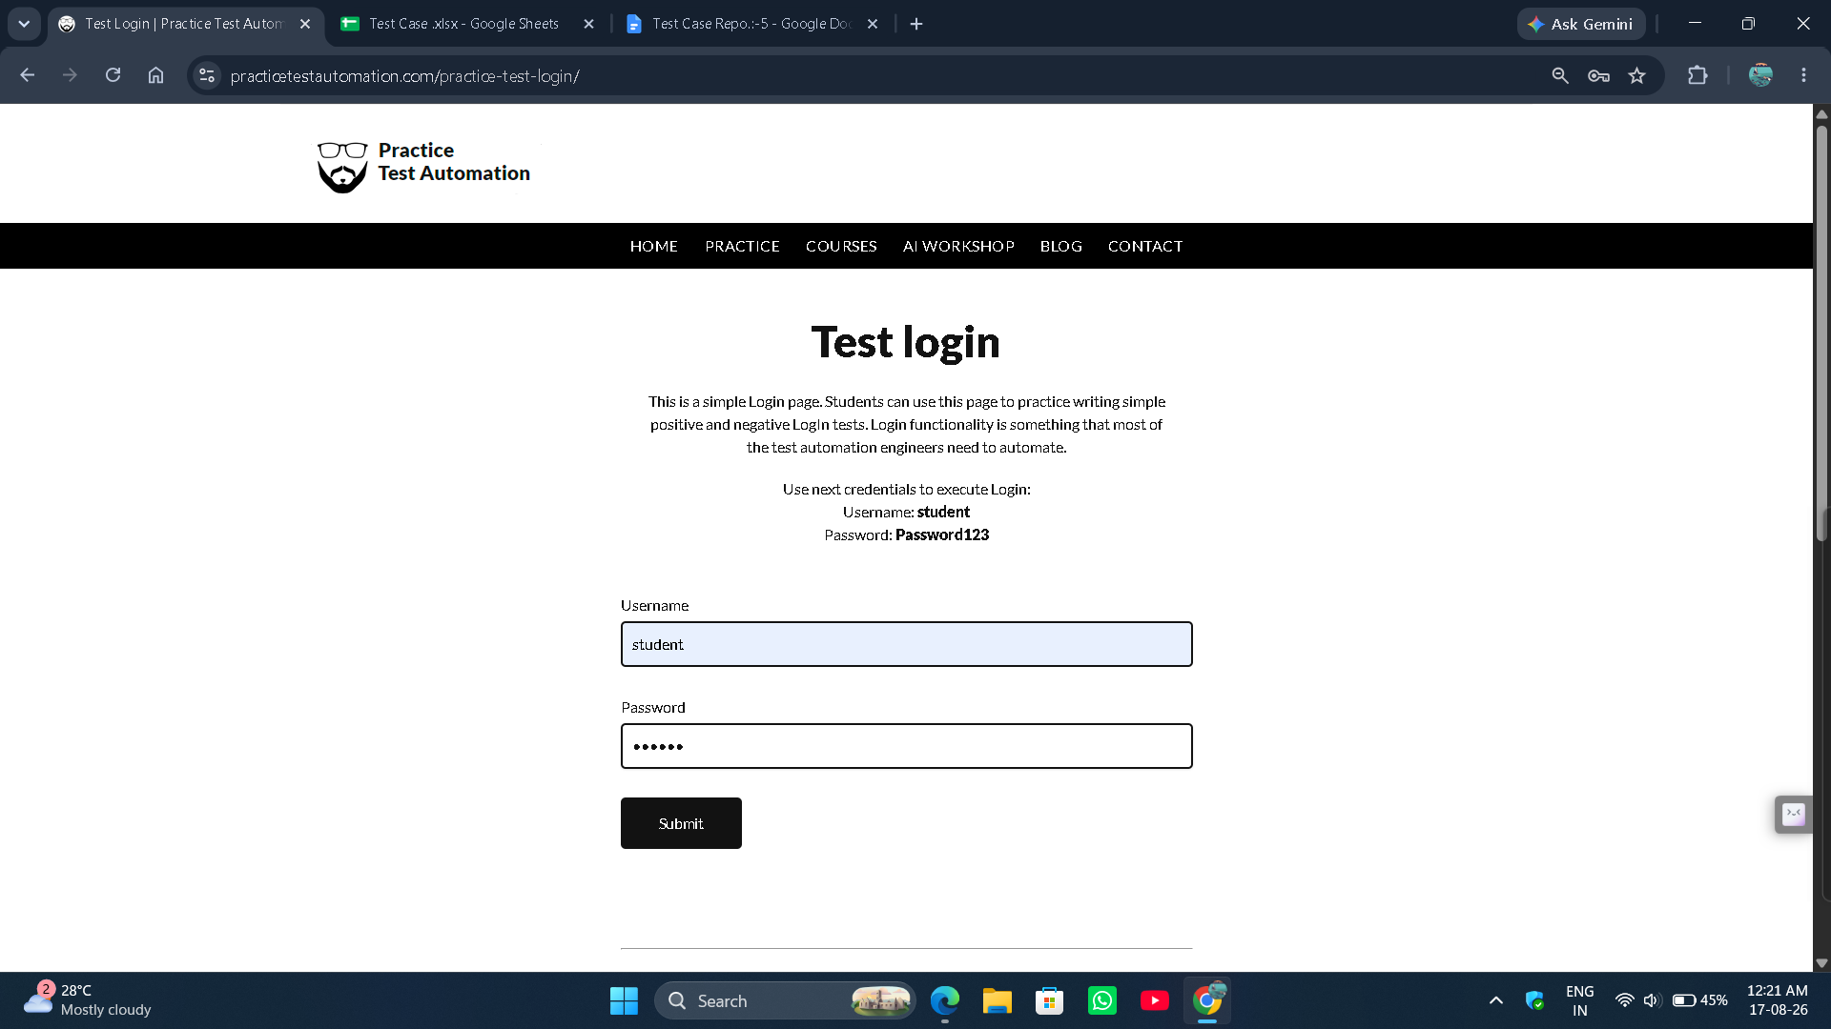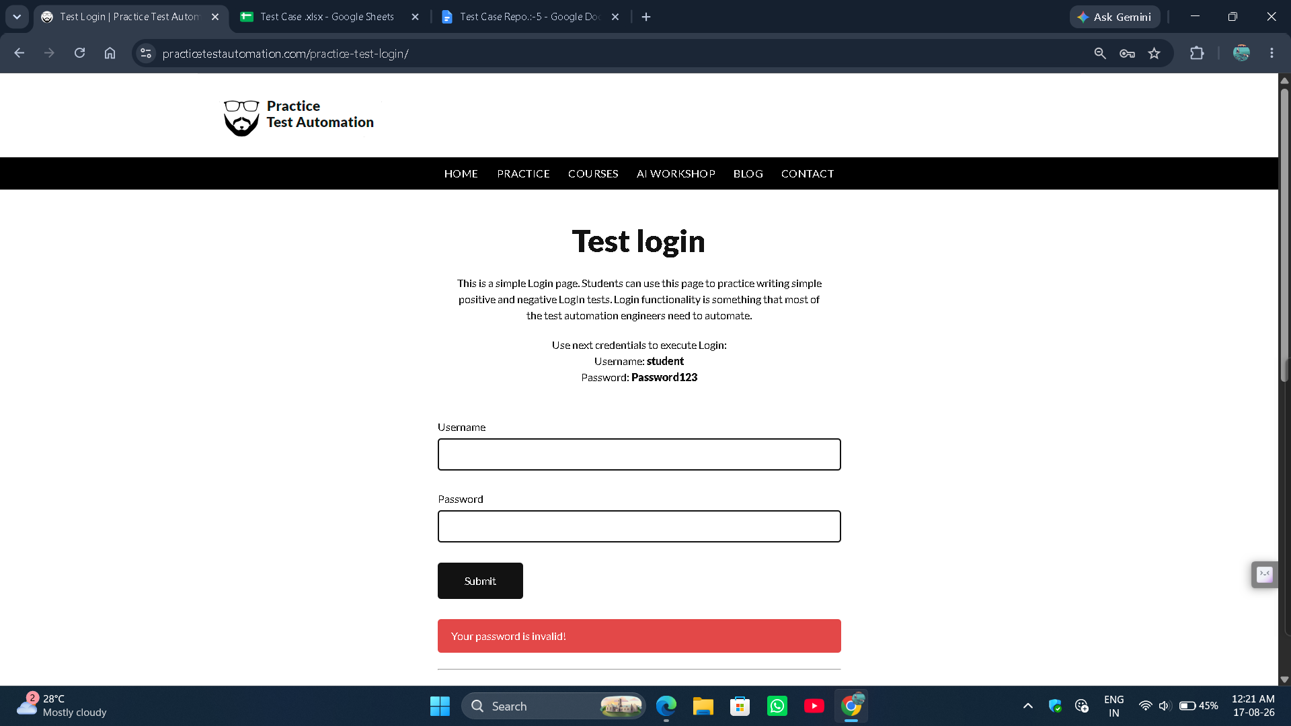

● Scenario ID: 5c
Scenario: Empty Username
Test Steps:
- Open Login Page
- Blank Username
- Valid Password
- Login

Screenshots: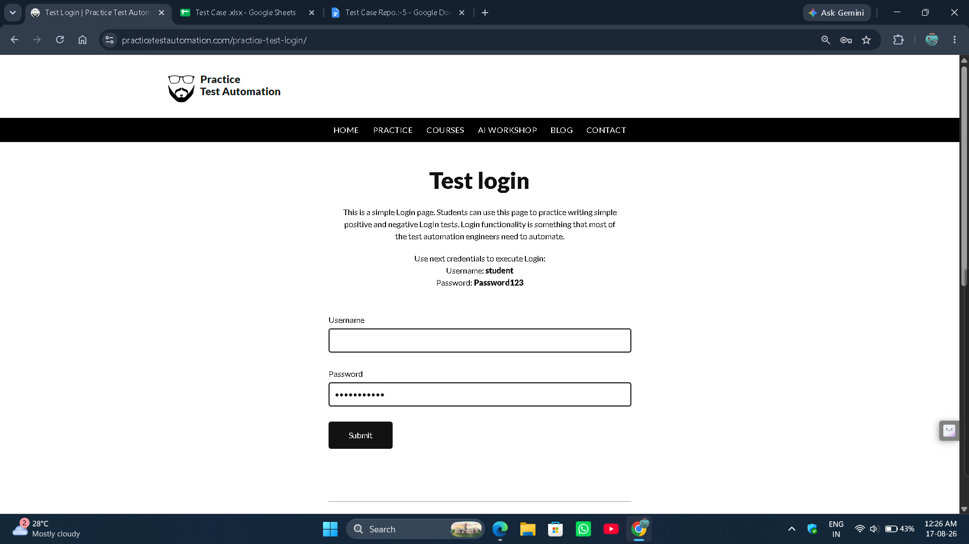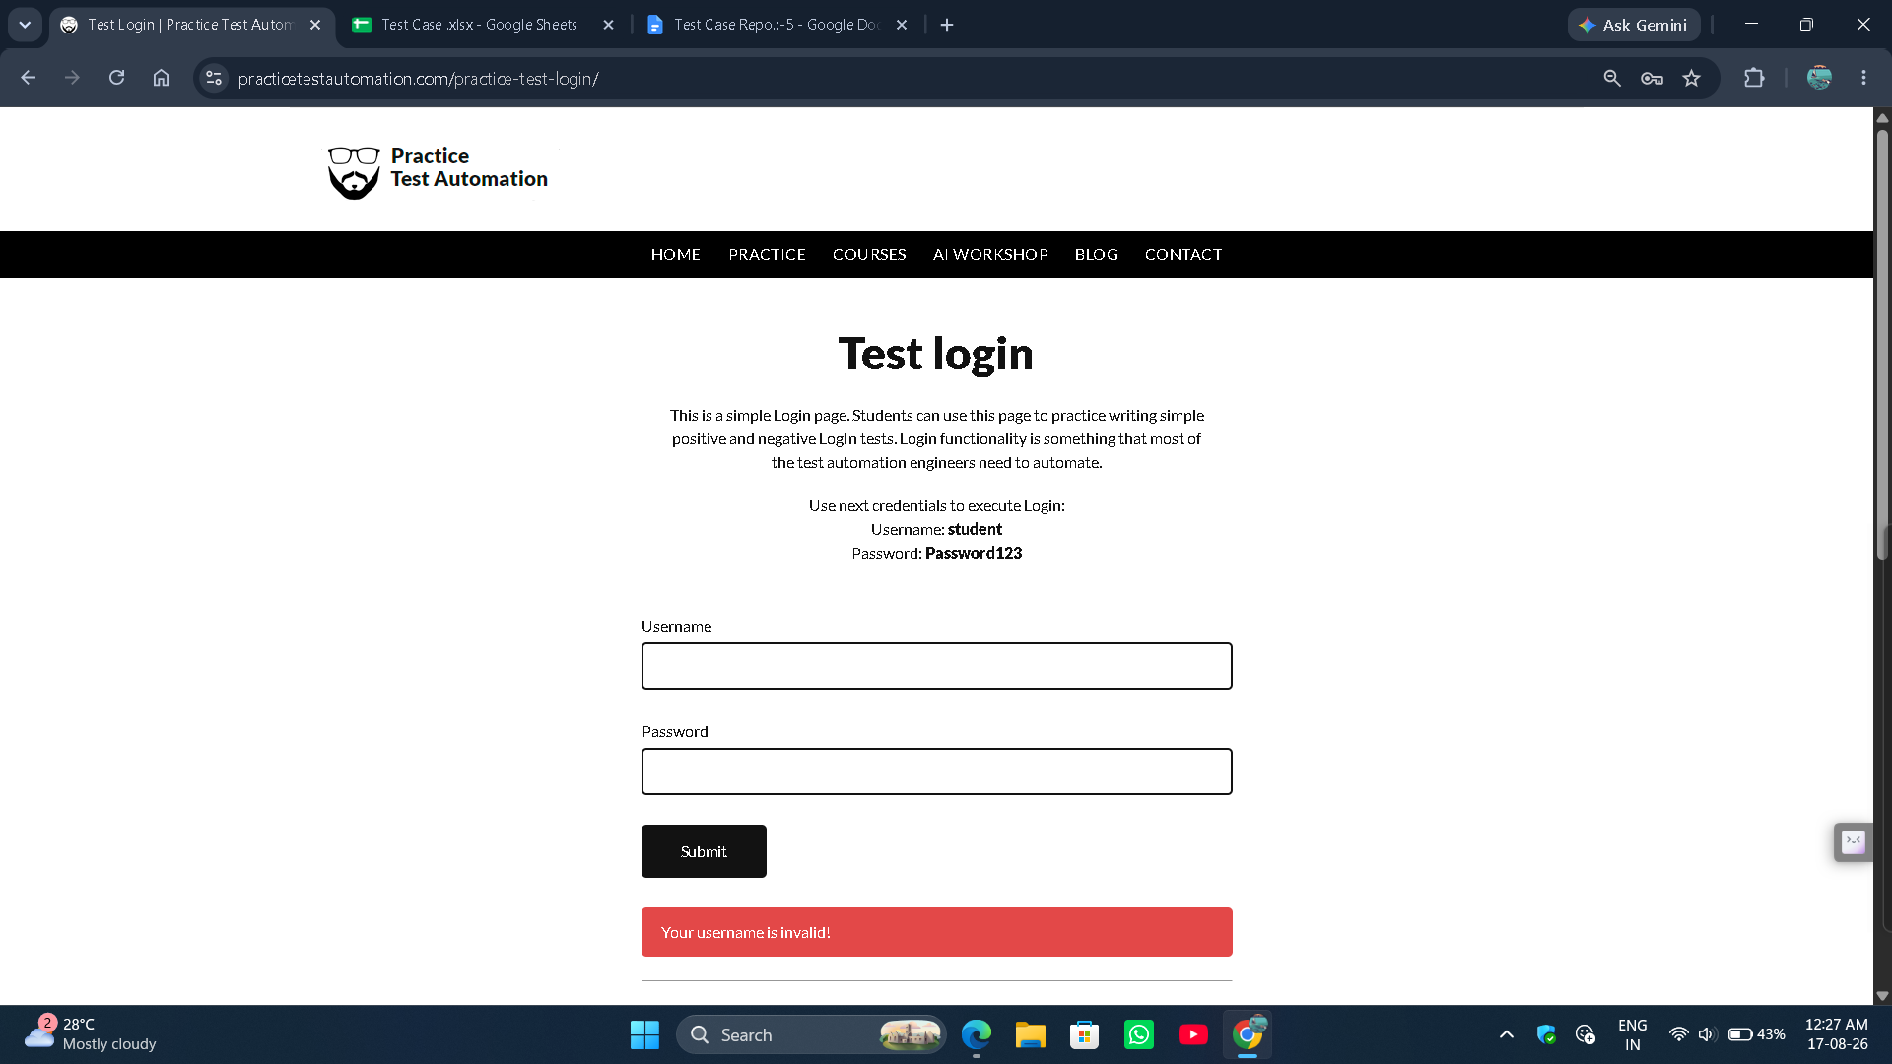

● Scenario ID: 5d
Scenario: Empty Password
Test Steps:
- Open Login Page
- Valid Username
- Blank Password
- Login
Screenshots:
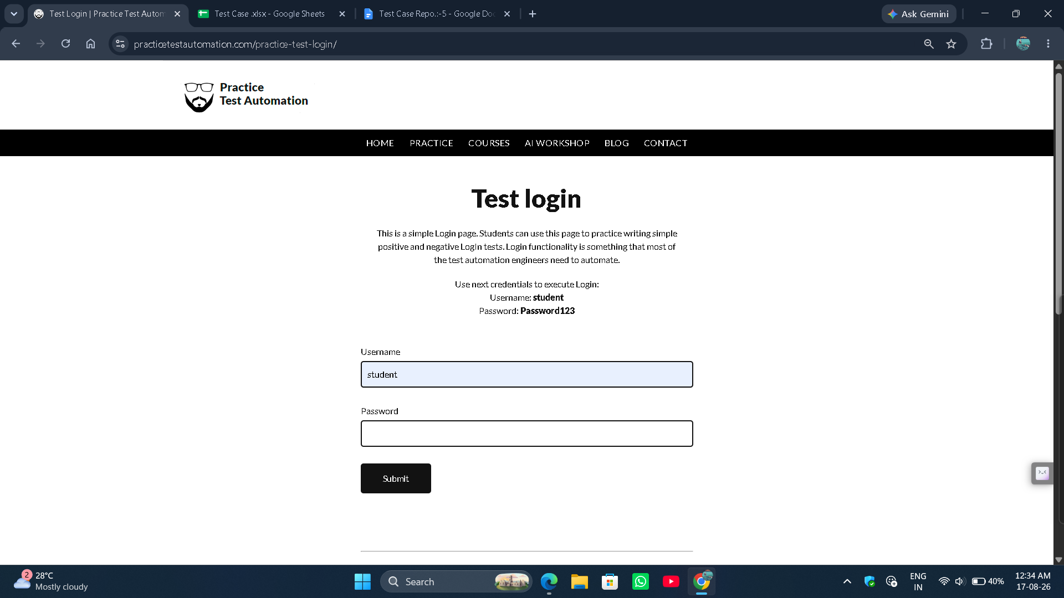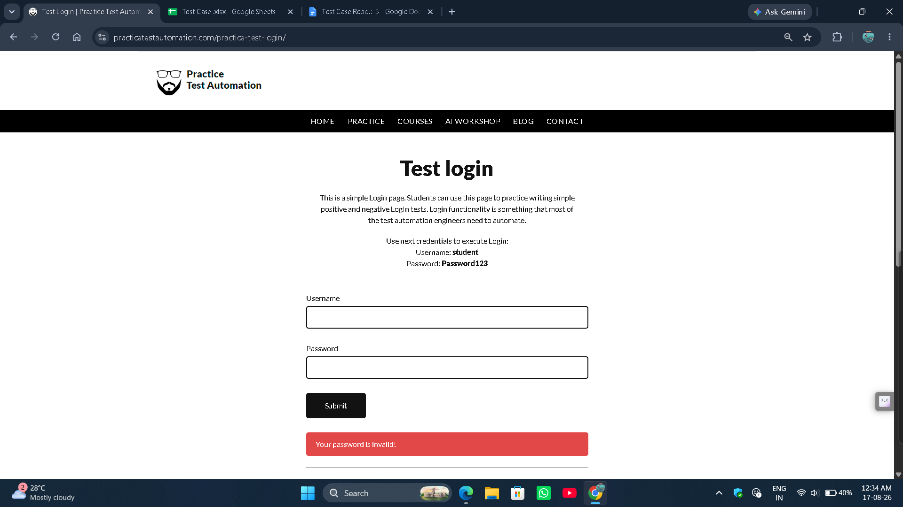

● Scenario ID: 5e
Scenario: Empty both Username/Password
Test Steps:
- Open Login Page
- Blank Username
- Blank Password
- Login
Screenshots: